

**953232 OOAD**

**Software Engineering**

**College Of Arts, Media And Technology, Chiang Mai University**

**2nd Semester / Academic Year 2020**

Lab Assignment 01 : Review on Class and Object

Name …………………Sahachan Tippimwong…………….. Student ID ……622115039…… Section……701……

**Class Creation**

1. Class declaration

Create a file name Student.java and insert the given source code.

public class Student{

public String name;

public String studentID;

public int score;

public void printScore(){

System.out.println(“I received ”+score);

}

}

1. Object instantiation  
   We can use object in the software by instantiating objects to use in software. Create a new class to run software by creating the “MainStudent1” class in the same project then adding the following code in class “MainStudent1”

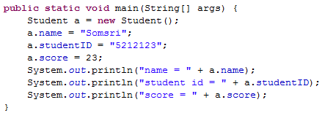

* 1. Add the following snippet at the end of the main methods  
     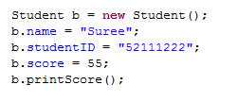  
     Then run the program, what is the additional output.

Answer………………………55…………………………………………………………………………………….

* 1. Add the following snippet at the end of the main methods,  
       
     What is the additional input, and why it shows the same result as b not as same as the value it shown before?

Answer………………………55 the reason that it shows the same result because the value in the object be is given to the object a………………………………………………

1. Method declaration  
   A method defines the behavior of the object. A method required the return type in order to return the operation result. The return type can be any data type. *void* means there is no return data from the method. The method also required input parameter as the source information to do some operation inside the methods.
   1. In this part, we will update the object of student class to compare the score between itself with another object. The method named “*compareScore*” is created. The method receives the other student object and compares the input student object with itself. The output is the integer value, if the return value is less than 0, the score of the object is less than the incoming object, if the return value is 0, both objects contain the same score, and if the return value is greater than 0, the current object contains greater score than new object. Adding the *compareScore* method as followed in the *Student* class  
      
   2. Create the new class name *MainStudent2* in *camt.oop.lab2* , and add the main method as followed  
      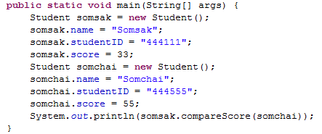  
      run the program, what is the result ?

Post the code here

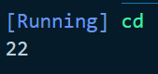

* 1. Create new class name MainStudent3 in the same package, then create three student objects using the information shown in the table below:

|  |  |  |
| --- | --- | --- |
| Name | StudentID | score |
| Apisit | “4921362” | 10 |
| Thaksin | “402561” | 56 |
| Samak | “489653” | 28 |

Then write the code to compare any two object and print the name of object which contains greater score.

Implement the compare code

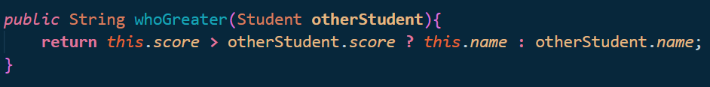

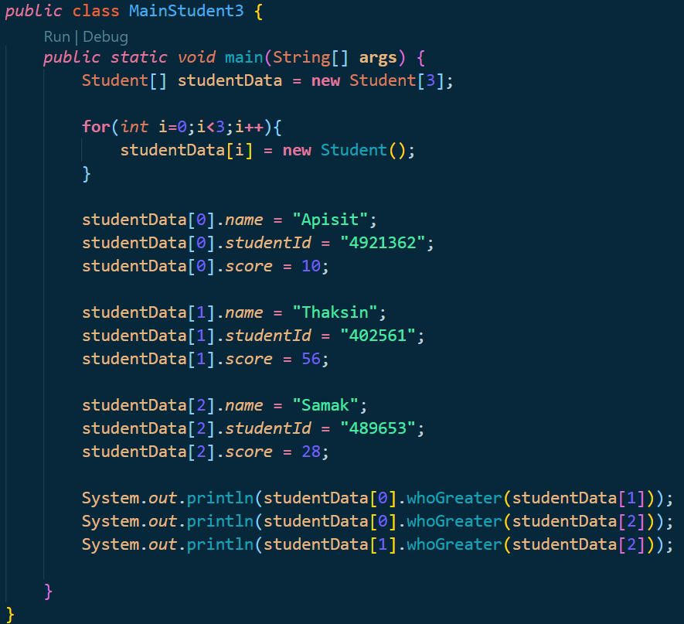

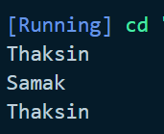

3. Create a program to simulate a car. A car is characterized by the manufacturer, the color and the speed. The speed represents the current speed of the car. When user applies the brake, the car will slow down the speed. On the other hand, when user speeds up the car, the speed of the car will be increased. In this system, the user will give the speed value to control both the speed up process and application of brake. For example, given that the current speed is 60.0 km/h. If user applies the brake with 10.0 degrees, the current will go down to 50.0 (60.0-10.0). If user speeds up with 15.5 degrees, the current will go down to 75.2 (60.0+15.5).

Implement the source code.

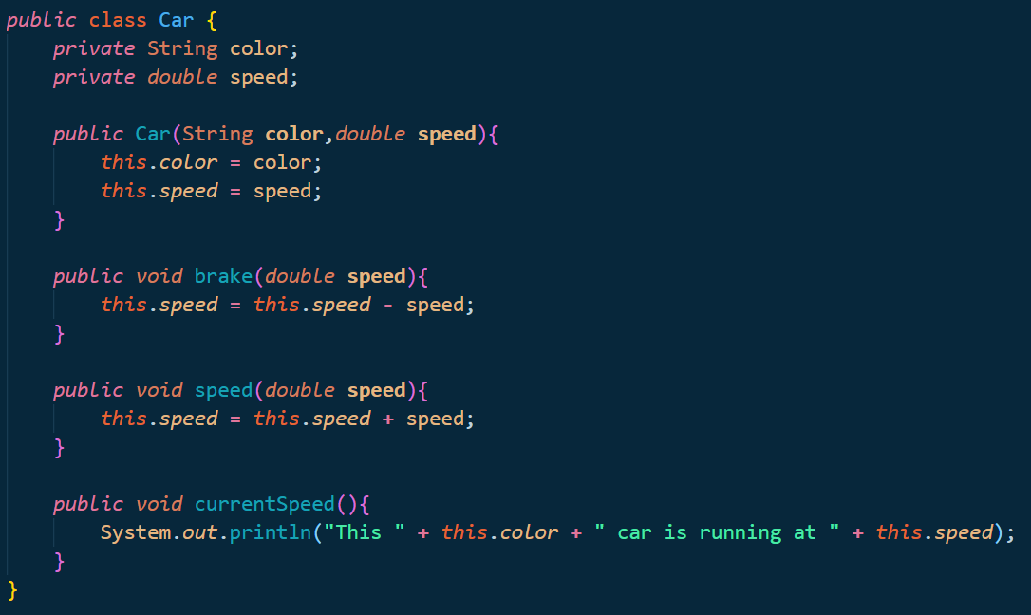Car.java

Post the code here

TestCar.java

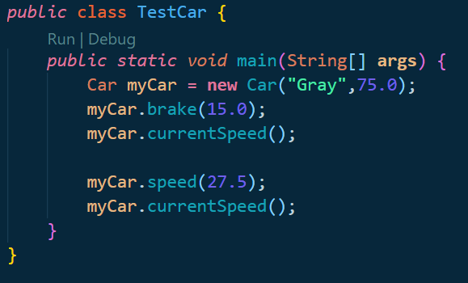

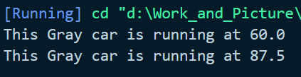

4. Create a program to simulate a rectangle. The rectangle is a 4 side 2D object. When user create a rectangle, the user can **either** input

* the origin point (the width and the height will be automatically set to 1), or
* the origin point, the width (w) and the height (h).

The user can view the area of the rectangle

* get the co-ordinates of the corner points of the rectangle. and
* Get the area of the rectangle.

Origin point

(x,y)

(x+w,y)

(x,y+h)

(x+w,y+h)

h

w

Rectangle.java (1)

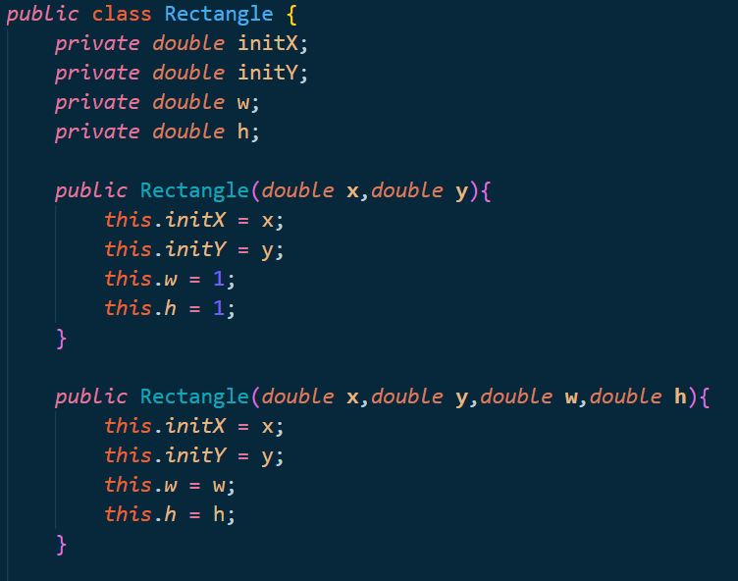

Reactangle.java(2)

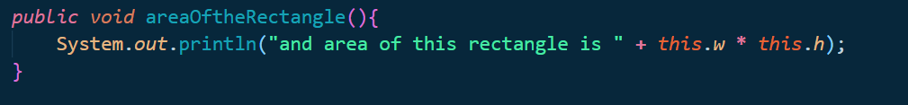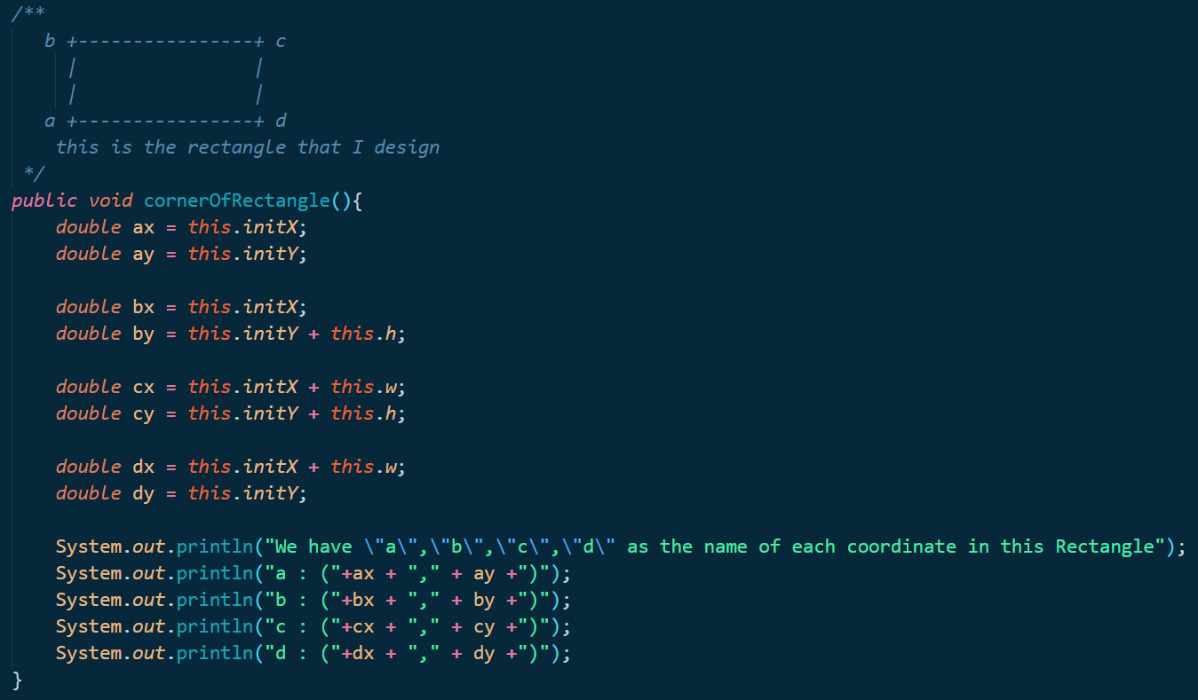

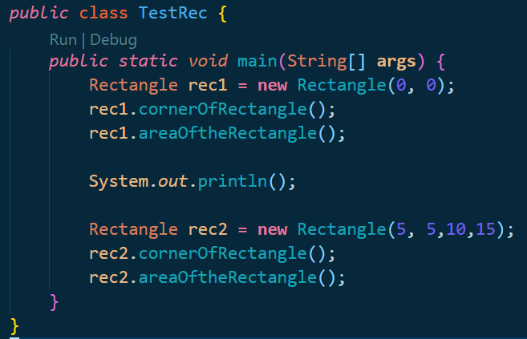TestRec.java

Output for rec1

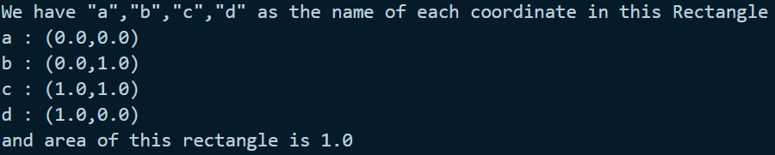

Output for rec2

